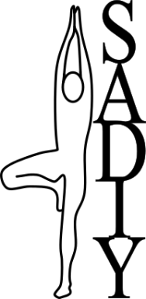
Membership Form 2024/25

Sheffield and District Iyengar Yoga
(SADIY)

SADIY's aims are to:
- bring together Iyengar Yoga practitioners in and around Sheffield
- promote the benefits and therapeutic aspects of yoga
- ensure people can learn yoga with well-trained and qualified Iyengar yoga teachers
- further Iyengar yoga in our region, e.g. subsidised classes for those who may not be able to access classes easily
- maintain links with other Iyengar Yoga groups and organisations.

Membership benefits include:
- free access to our library of yoga reference books and DVDs
- SADIY journal (edited and written by local Iyengar yoga students and teachers)
- membership of the national Iyengar Yoga Association, IYUK, (worth £21.00 at individual rate for 2024-25) which includes twice-yearly members’ magazine, Iyengar Yoga News
- being part of a wider yoga community
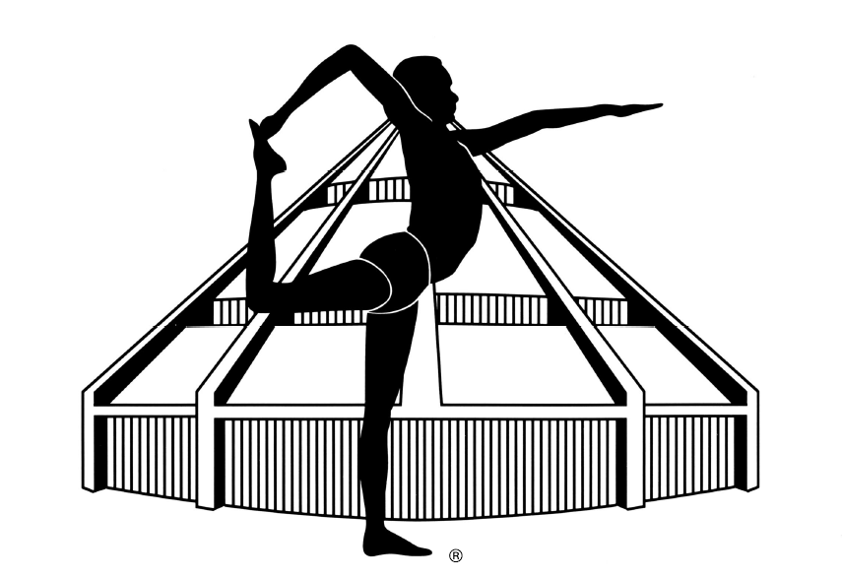
- reduced fees to events and workshops run by SADIY.
For more information visit the SADIY website at http://www.yogasheffield.org

SADIY membership is from date to 31st March 2024 and costs £21 (£10 if you join IYUK in 2023-24 through another affiliation group).
To join or renew membership of SADIY, or to let us know of change of details, please complete this form, and send it to:
SADIY Membership Secretary
Lorraine Bonete, 18 Broad Elms Lane, Sheffield, S11 9RQ
email: lorraine.bonete@gmail.com
If you need a receipt, please tick box and I will email one to you. ☐
Otherwise please send a SAE.

SADIY – 2024/25 |  | Membership number: Click or tap here to enter text.  For office use
Surname |  | Click or tap here to enter text.
Firstname |  | Click or tap here to enter text.
Address |  | Click or tap here to enter text.  Click or tap here to enter text.  Click or tap here to enter text.
Telephone |  | Click or tap here to enter text.
Email |  | Click or tap here to enter text.
Date |  | Click or tap to enter a date.
I wish to become a member / renew my membership of SADIY.
☐ | I enclose a cheque for £Click or tap here to enter text.
☐ | I have paid by BACS/standing order for £Click or tap here to enter text.  SADIY bank details: sort code: 54-41-50 account no: 53174151
If you are joining IY(UK) separately in 2024-25 please give the name of your other affiliation body: Click or tap here to enter text.
or your IYUK number: Click or tap here to enter text.

Please note that, to comply with the provisions of the General Data Protection Regulation 2018, SADIY will not release the details you give us here to any external party without first seeking your permission. These contact details are made available to the Membership administration of IYUK, to which SADIY is affiliated. This information is collected, stored and processed for the purposes of SADIY and IYUK membership administration (including mailing of communications) and, where consent is given, to enable teachers to be contacted by other teachers and by enquirers seeking yoga classes.
Neither SADIY nor IYUK sell or exchange membership lists with other organisations.
Details of our procedures and policies for how we collect, store, use and share data, and how long we keep it for can be found on our website.

